

# VR for Hospital Fire Management

[FinalProject.skp - Google Drive](https://drive.google.com/file/d/1DnJOkvvzFsuij7gl3zI-Rs7_wImymEue/view) Link of Final Model

**INDEX OF CONTENT**



**INFRASTRUCTURE PLANNING**



**MODEL PRESENTATION**



**OTHER IMPORTANT INITIATIVES TO BE TAKEN**



**WEEK-WISE PROGRESS**

**HOSPITAL INFRASTRUCTURE PLANNING**



**A**

**Architectural planning**



**B**

**Layout planning**



**C**

**Interior planning**





# 01

Sufficient open space between two buildings so as to minimize ﬁre spread possibilities from other neighboring structure

# 03

The size and no. of occupancy, lobbies, staircase, ramps etc is sufficiently wide

**ARCHITECTURAL PLANNING**

# 02

There is enough space for movement and parking of ﬁre ﬁghting vehicles, ambulances, etc in the premises and wide road approach to the building.

# 04

Ensuring movement of traffic and quick evacuation during emergencies.



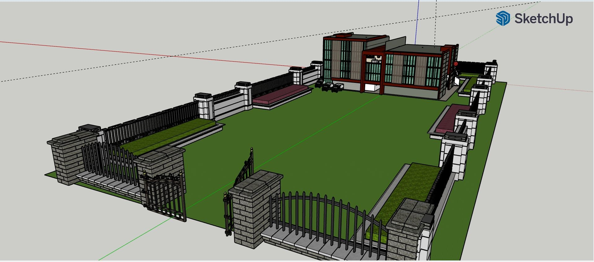**ARCHITECTURAL PLANNING: SUFFICIENT OPEN SPACE**

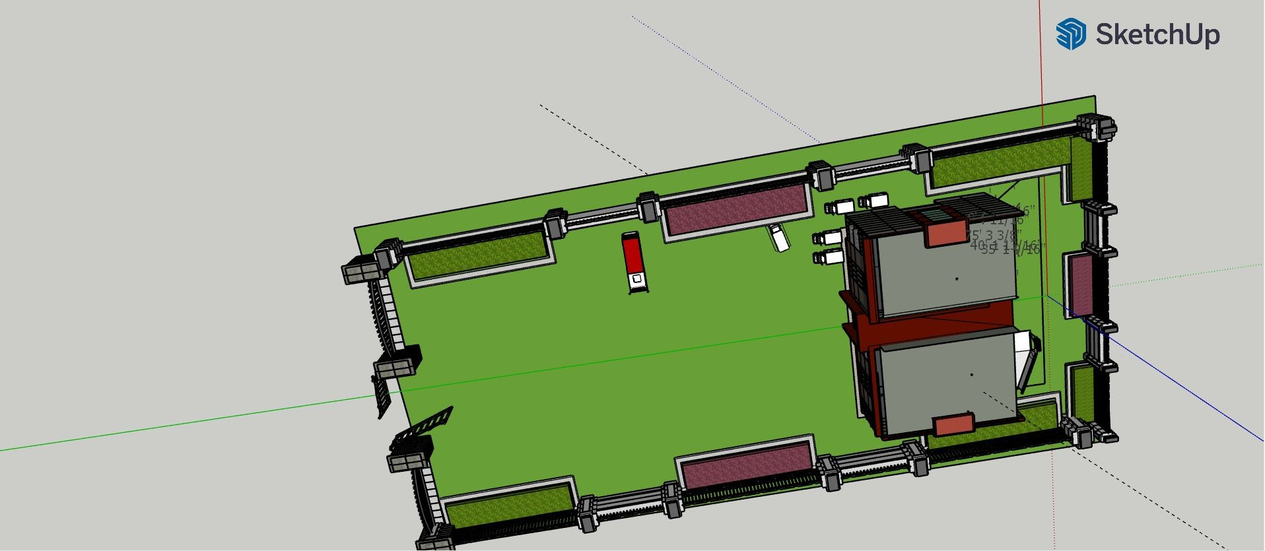**ARCHITECTURAL PLANNING: ENOUGH PARKING SPACE**

**ARCHITECTURAL PLANNING: LOBBIES AND OCCUPANCIES**

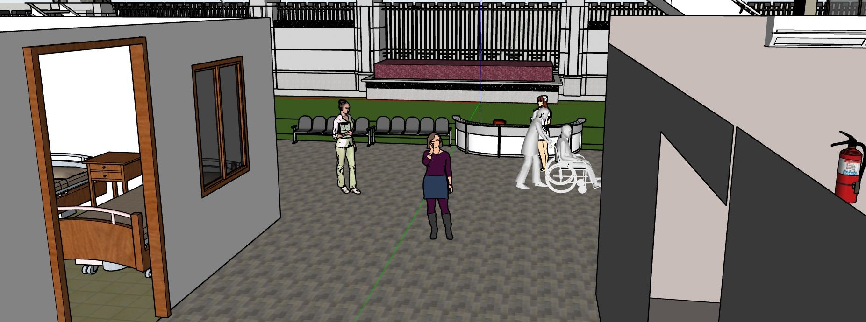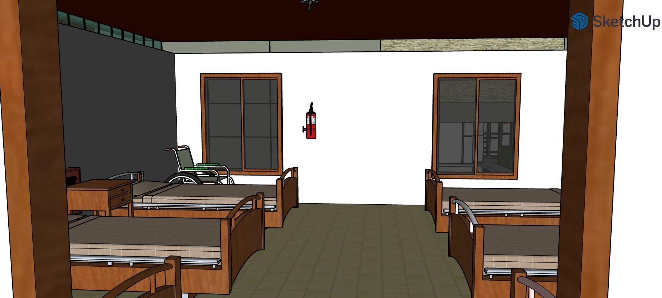

**ARCHITECTURAL PLANNING: TRAFFIC MANAGEMENT**

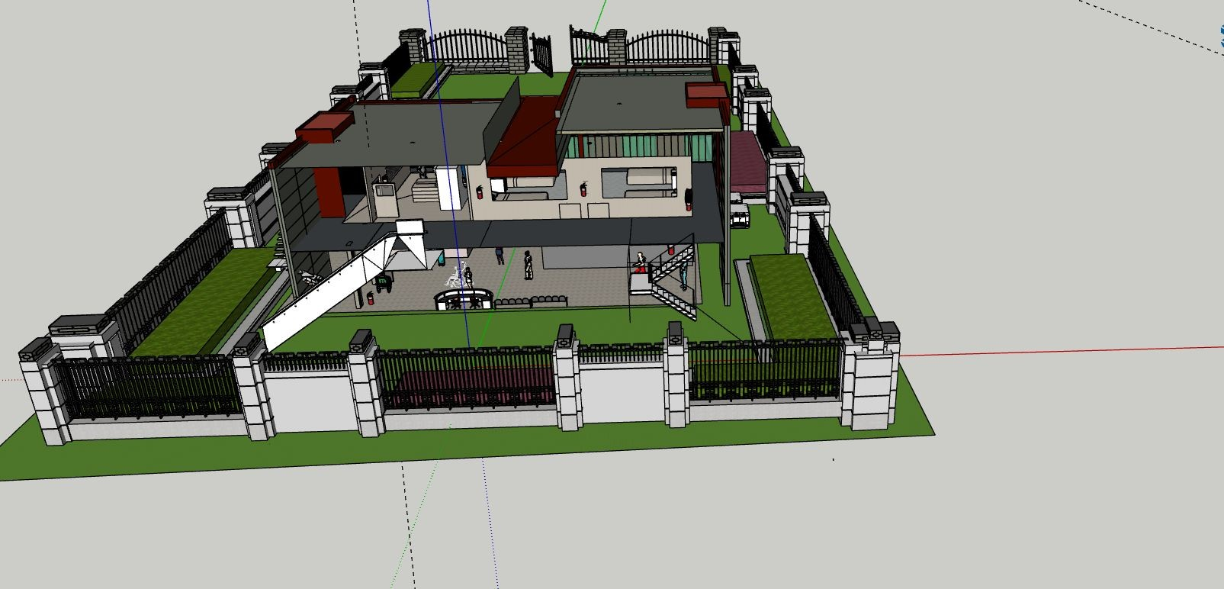



# 01

The design of the building structure so planned that it allows pressurized exclusion of smoke in case of ﬁre or any smoke leak.

# 03

Safe and easy means of access provided to and in every place of work / in patient area.

**LAYOUT PLANNING**

# 02



Must have enough doors and widows

# 04

In case of emergency , safe and rapid exit provided for all occupants. Each building must have separate ﬁre exit, staircase with proper signage



**LAYOUT PLANNING: SMOKE EXCLUSION**

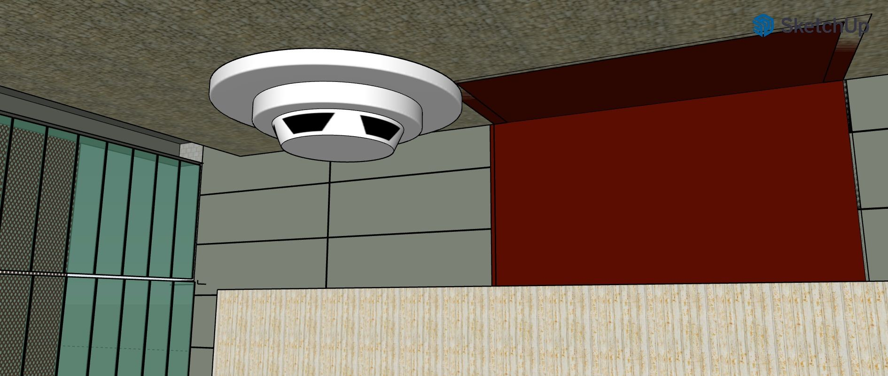

**LAYOUT PLANNING: DOORS AND WINDOWS**

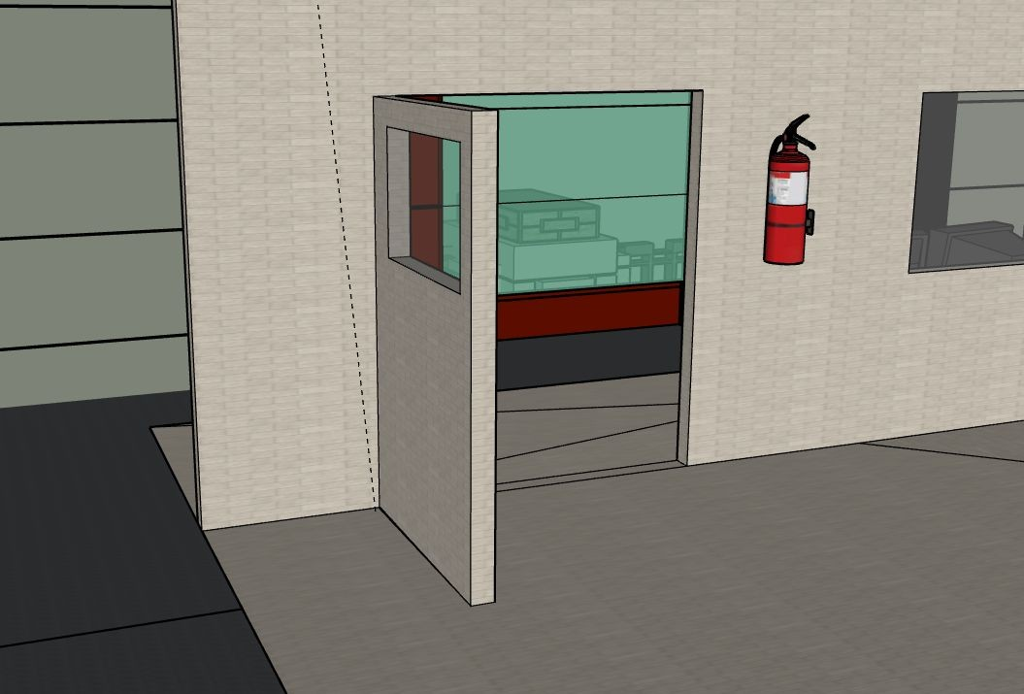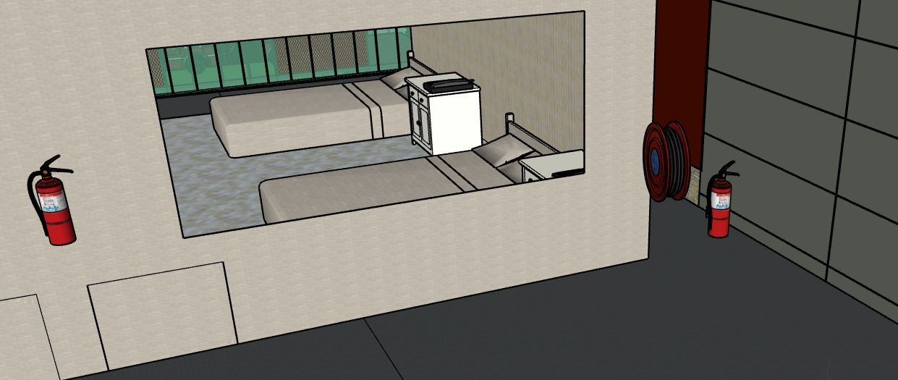

**LAYOUT PLANNING: EMERGENCY EXITS**

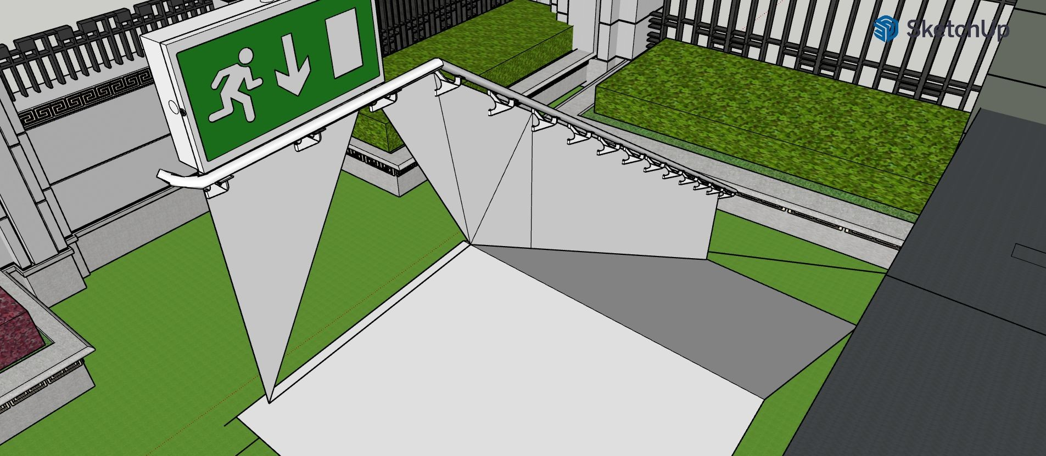

**LAYOUT PLANNING: EASY ACCESS**

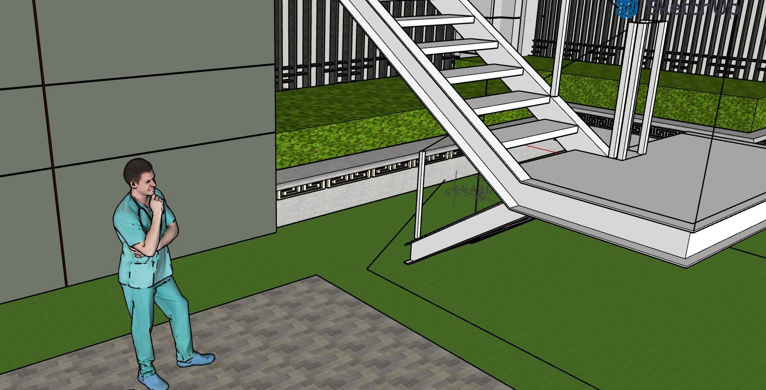



# 01

The ﬂoors are so designed that they are free from obstructions , are slip resistance and even.

# 03

Staircase, ramps should be provided with substantial handrails and other suitable support to prevent slipping , where ever necessary

**INTERIOR PLANNING**

# 02



Openings in ﬂoors are securely fenced or covered

# 04

Interior should have ﬁre proof doors, windows, walls and roof covered with ﬁre proof materials



**INTERIOR PLANNING: STAIRS AND OPENINGS**



**MODEL PRESENTATION**

**INITIATIVES NEEDS TO BE TAKEN BY THE PEOPLE**



Coordination & Management



Planning & Training &

Drills



Information &

Communication



Logistics &

Supply & Finance

Management

**FEATURES OF THE MODEL**



**Fire & Smoke Alarms**



**Fire extinguisher**



**Enough ﬁre exit doors**



**Wheelchairs exit stairs**



**Fire ﬁghting vehicle**



**Air ventilation**

**WEEK WISE PROGRESS**

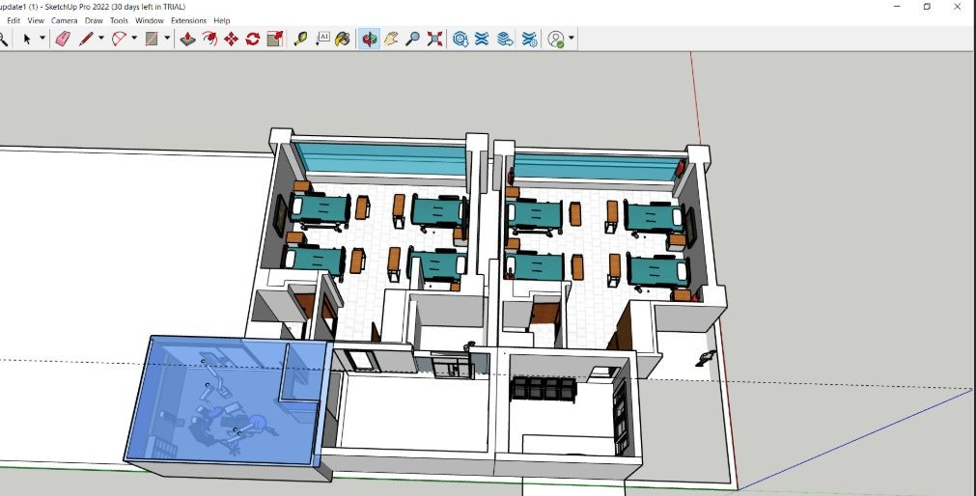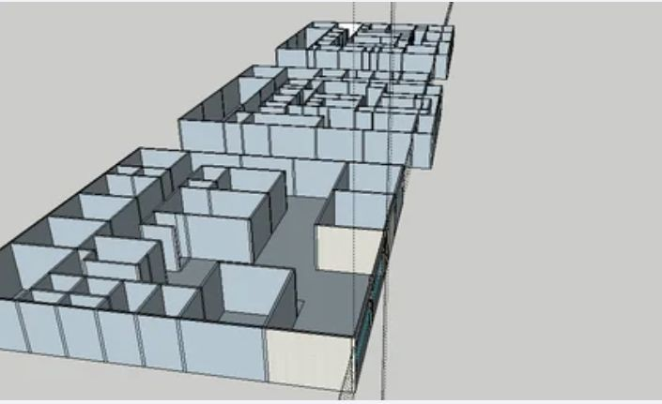

**THANK YOU**

